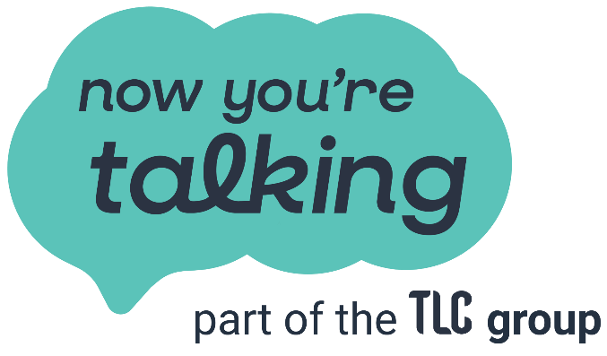

Relationships & Business Operations Manager
Now You're Talking is looking to recruit a dynamic colleague to be the link between our therapists, corporate clients, and our day to day operations.
If you’re experienced in relationship management, onboarding, and thriving in fast-paced start-up environments—and want to contribute to doing good, then look no further!
In this role, you’ll manage relationships, operations, and ensure our service excellence. You will onboard new therapists, manage corporate accounts, and streamline operations to ensure top-quality service—all while driving our mission to enhance mental health and wellbeing.
As a profit-with-purpose organisation, the majority of our profits are reinvested into Talk Listen Change to further our impact. Talk Listen Change, our parent company, do amazing life-changing work in communities across the UK - helping individuals and families build safe, happy and healthy relationships.
This role is our second permanent colleague appointment, so this is a fantastic opportunity for the right person to design ways of working, play an integral role in our start up and create a legacy of innovative mental health services. Being a small team also means that you might need to get involved in areas outside of the job description, but that’s what can make it fun and exciting for the right person.
Location: We recognise that a one-size-fits-all approach doesn’t work for everyone. We’re committed to offering flexible working options that suit your individual needs. This role is a hybrid role which can be done remotely or in our office in Trafford, Manchester.
Working Pattern: This is a full-time role, however, we encourage open conversations to find the best balance between professional and personal commitments. We believe that flexibility not only supports well-being and work-life balance but also drives creativity and success.
Salary: Starting from £27,784 FTE based on 37 hours per week
Recruitment Process: We truly believe that building strong relationships starts from the very first conversation. Our recruitment process is designed to be open, friendly, and transparent—just like how we approach our work every day.
To apply: Please send your CV with a covering letter outlining your fit for the role to hello@nowyouretalking.co.uk. CVs should be no more than two pages with a minimum Font Size of 11. Your covering letter should be no more than two pages and address your reason for applying and how you meet our essential criteria.
If you would like to chat in more detail about the role please contact our Managing Director.
Helen Stuart helenstuart@nowyouretalkingtherapy.co.uk
Closing Date 15th May 2025

Relationships & Business Operations Manager
This role is the key link between our therapists, corporate clients, and delivery partners making sure everything runs smoothly, relationships stay strong, and our high standards of service are met.
The role is responsible for onboarding new therapists, nurturing ongoing partnerships, and ensuring compliance with industry standards. It also plays a big part in creating a thriving therapist community and enhancing the overall experience for both clients and partners.

What You’ll Be Doing
1. Supporting & Growing Our Therapist Community
- Onboarding: Guide new therapists and delivery partners through a seamless onboarding process.
- Ongoing Relationships: Build and maintain meaningful relationships with our therapists, supporting their engagement, retention, and professional development.
- Community Building: Organise activities and initiatives to foster collaboration and knowledge-sharing within the therapist network.
- Plan and coordinate events that help therapists connect, learn, and grow.
2. Managing Corporate Client Relationships
- Be the main point of contact for our corporate clients, ensuring they receive top-quality service and support.
- Manage the full client journey, from attracting new corporate partners to onboarding, retention, and long-term success.
- Work closely with corporate partners to tailor services and ensure they’re getting the most value from their partnership.
3. Improving Business Processes & Service Delivery
- Continuously refine and improve business processes to enhance client retention and satisfaction.
- Monitor customer feedback, identify trends, and implement action plans to improve the experience for therapists and clients.
- Map out and optimise workflows to ensure everything runs as efficiently as possible.
4. Ensuring High Standards & Compliance
- Oversee audits and quality checks to make sure therapists meet all necessary professional and regulatory standards.
- Stay up to date with industry regulations and ensure any necessary changes are implemented.
- Keep therapist records and database information accurate, up-to-date, and well-maintained.
6. Working Closely with Our Parent Charity & Internal Teams
- Collaborate with the parent charity and internal teams to deliver outsourced services, such as data management, reporting, and website performance.
- Strengthen internal relationships and ensure service level agreements (SLAs) are met.
7. Driving Growth & Representing the Brand
- Support business development by attending industry events and helping expand Now You’re Talking’s reach and impact.
- Assist the Managing Director in building new partnerships and growing the organisation.
- Act as a brand ambassador, representing our values and mission in everything you do.

What We’re Looking For
Essential Skills & Experience:
✅ People-Focused Relationship Management: Strong experience in building and maintaining relationships with third parties.
✅ Recruitment & Onboarding: Experience in bringing new professionals / clients on board, ideally in service-based industries.
✅ Process Improvement: Ability to analyse processes, spot inefficiencies, refine workflows, and optimise service delivery.
✅ Database Management: Confident in keeping customer and supplier databases accurate and up to date.
✅ Client Satisfaction & Feedback Management: Skilled at gathering and analysing feedback to improve services.
✅ Decision-Making & Problem-Solving: Able to navigate challenges and make confident, informed decisions.
✅ Written Communication: Strong writing skills for professional communication, reporting, and documentation.
✅ Corporate Client Management: Experience in working with corporate clients, managing service delivery, and maintaining strong partnerships.
✅ Team Collaboration: Ability to work cross-functionally with internal teams and partners to support service excellence.
✅Experience in fast-paced start-ups—building things from scratch, managing every detail, and taking on extra responsibilities to drive success.
Desirable Skills & Experience:
➕ Mental Health/Wellbeing Background: Any experience in therapy, coaching, or wellbeing services would be a plus!
➕ Brand Representation: Comfortable representing an organization at industry events and acting as a public-facing ambassador.
➕ Governance & Compliance: Experience of working in a regulated environment with knowledge of auditing, regulatory requirements, and industry standards.
➕ Event & Community Coordination: Experience in organising events and fostering strong communities.

